**Case Study Assessment**

**Name:** Lakshmi Konamma M

**UID :** 259086

**Email :** [Lakshmi.KonammaM@ust.com](mailto:Lakshmi.KonammaM@ust.com)

**Case Study 1: Retail Sales Data Processing (using Azure blob storage and Azure Data Factory)**

**1.Setting up Azure blob storage, created container and uploaded the CSV file.**

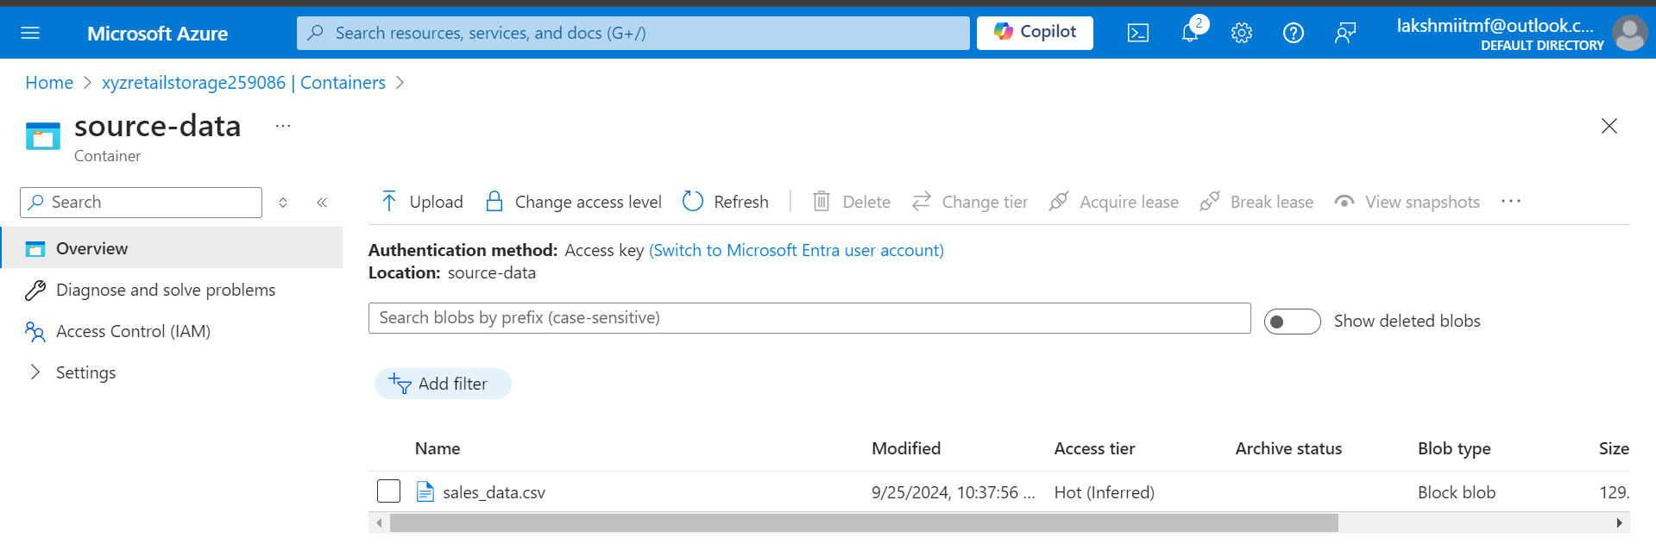

**2.Configure Azure Data Factory**

**a. Created Azure Factory**

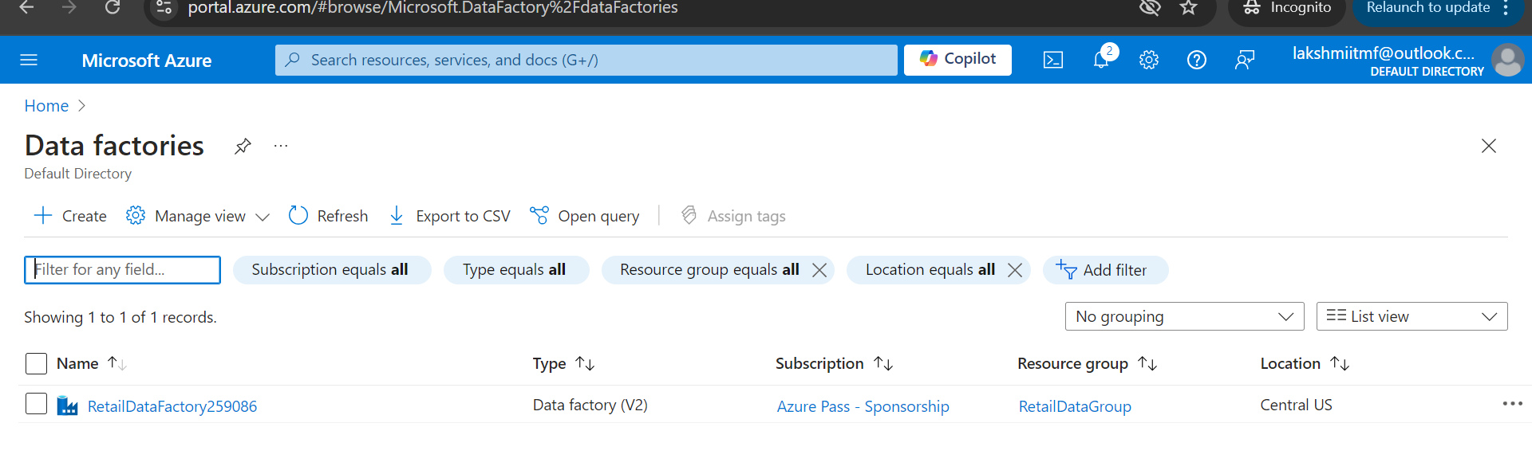

**b.** **Created Link Service**

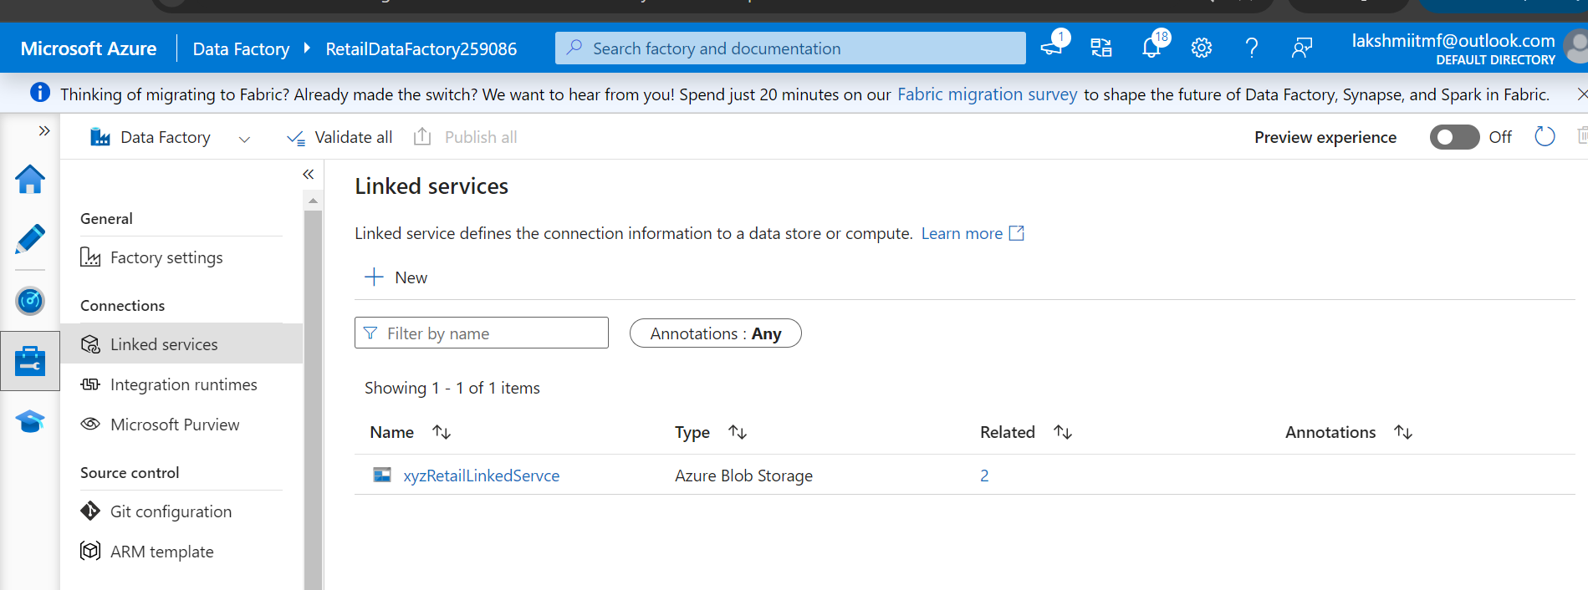

**c.** **Created Dataset Source and destination**

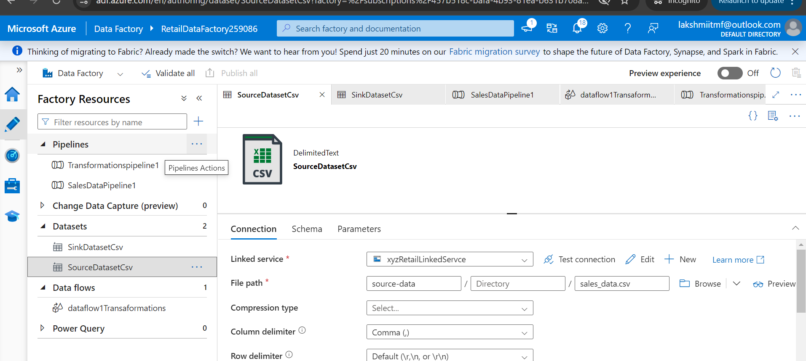

**3.** **Build and Configure Pipeline**

**a. Created pipeline with Copy data activity select source and sink file**

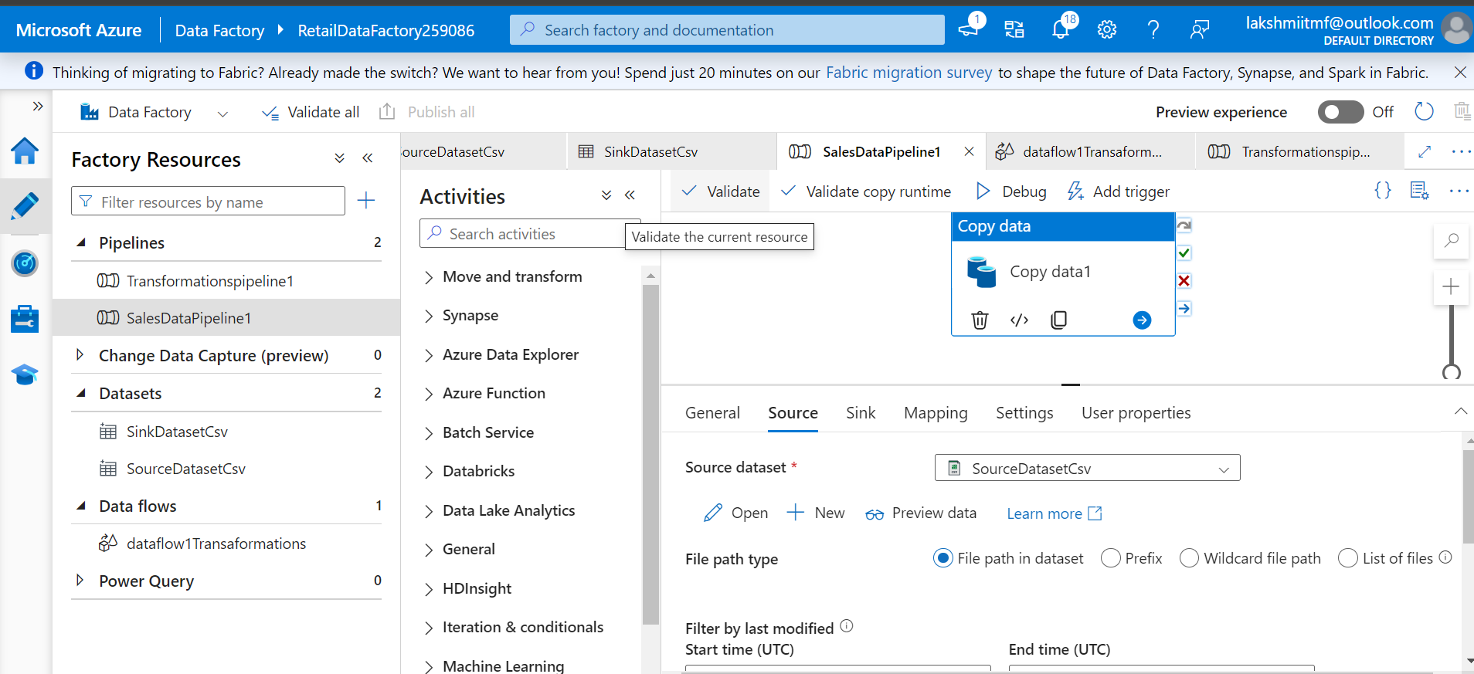

**b. Optional Data Flow**

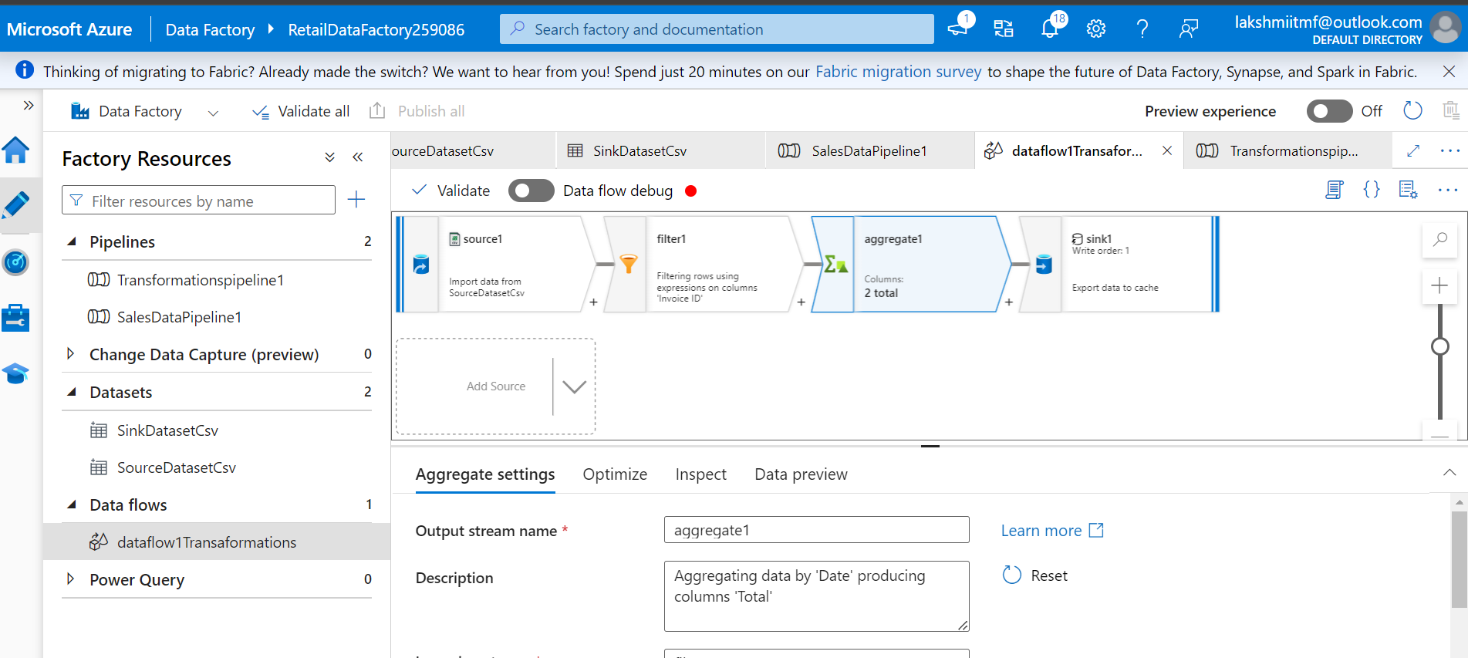

**4. Automate and Monitor**

**a. Create Trigger:**

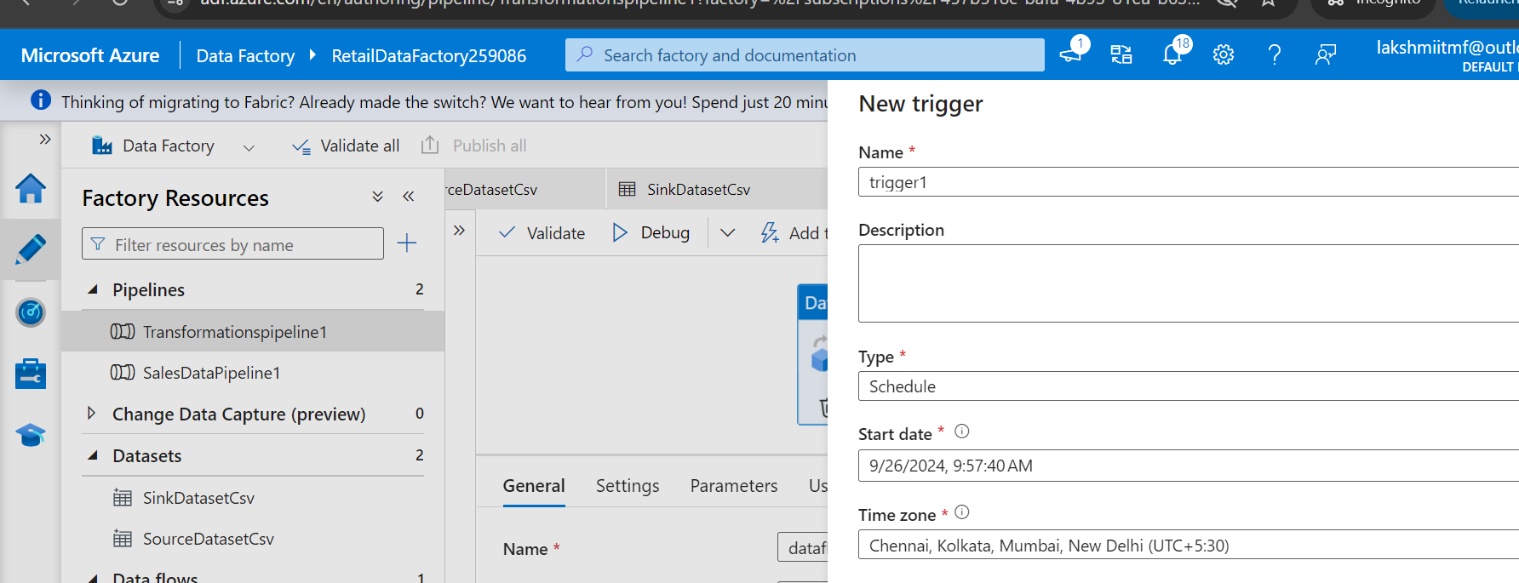

**b. Monitor Pipeline:**

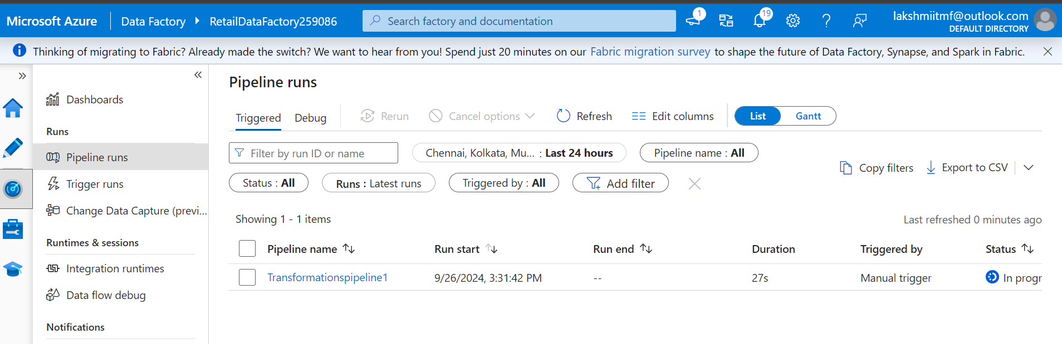

**Case Study 2: Retail Sales Data Processing (using Azure DataBricks)**

**1.Setting up Azure blob storage, created container and uploaded the CSV file.**



**2. Set Up Azure Databricks**

**a. Create an Azure Databricks Workspace**

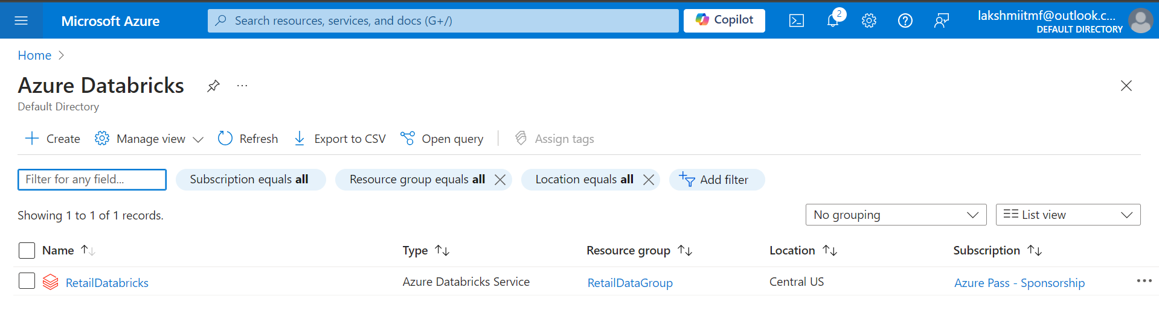

**b.** **Creating cluster**

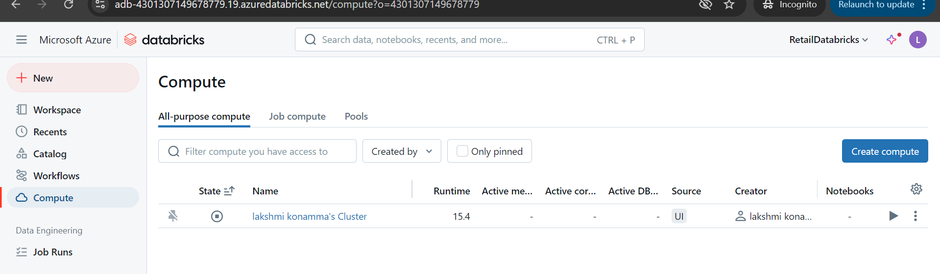

**c.** **Created Databricks notebook**

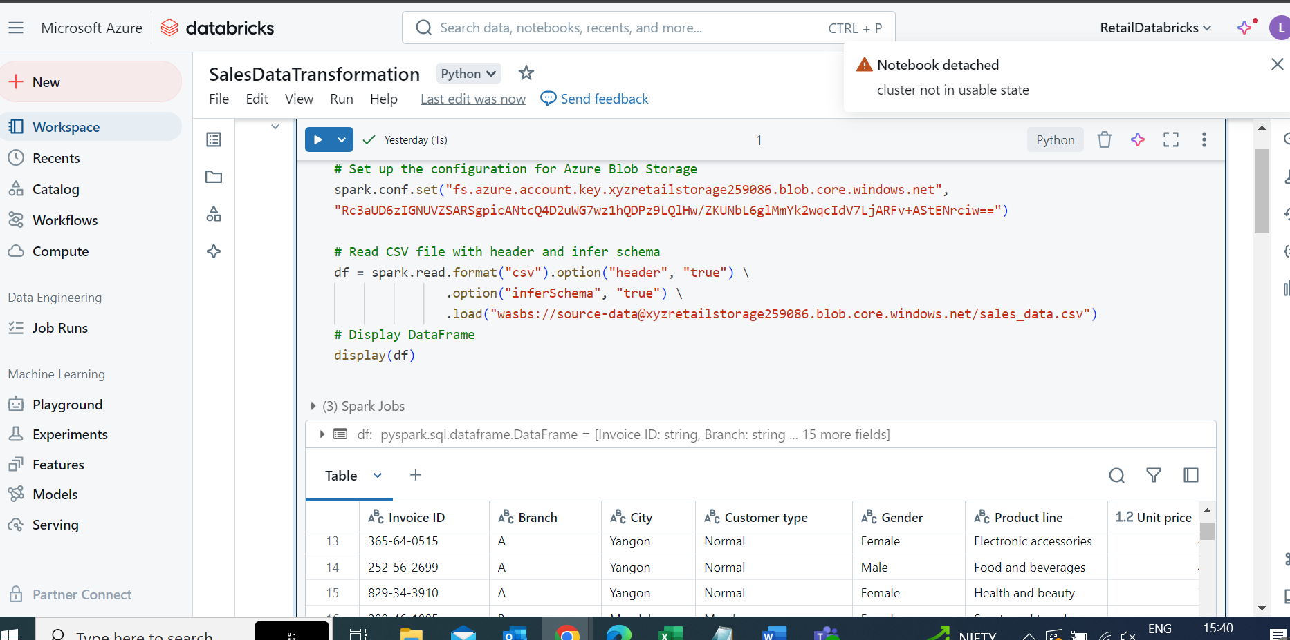

**write the transformed data back to the transformed-data container.**

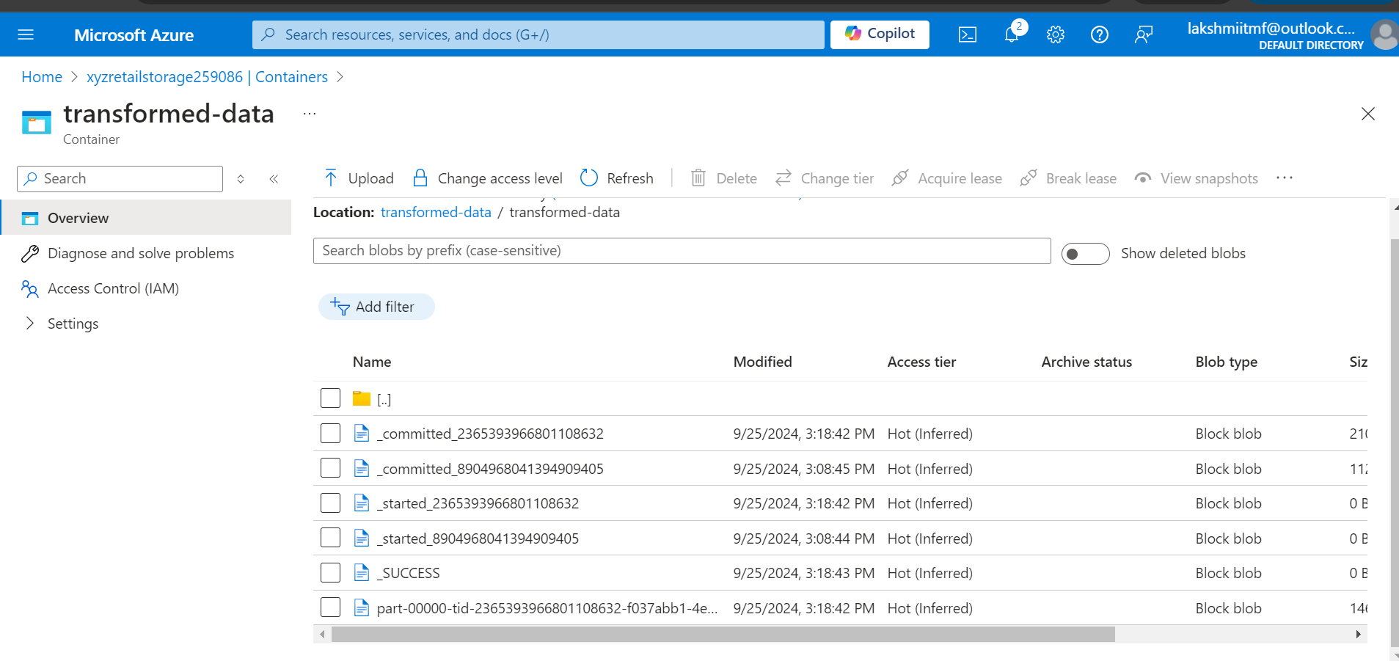

**Case Study 3 : Analyzing Retail Sales Data with Azure Synapse Analytics**

**1.Setting up Azure data lake storage, created container and uploaded the CSV file.**

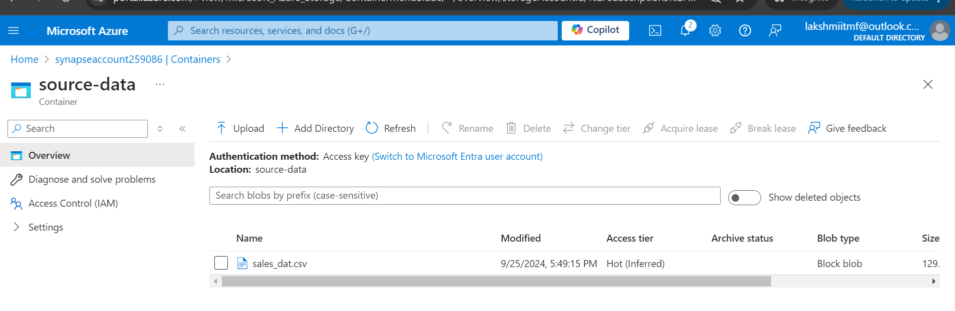

**2.Creating Azure Synapse.**

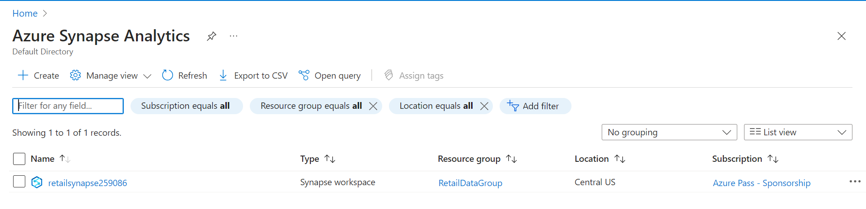

**2.Create a Dedicated SQL Pool:**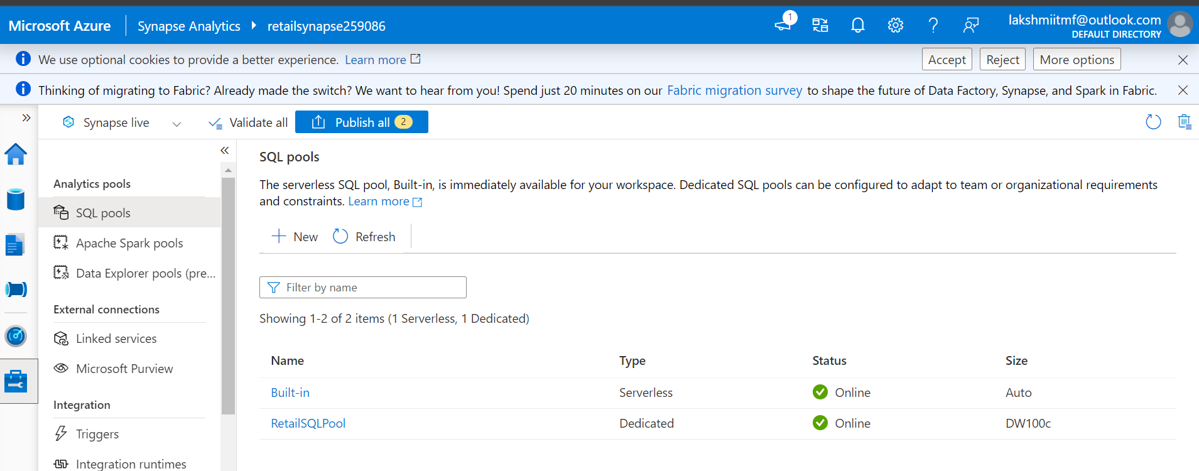

**3. Ingest Data into Azure Synapse Analytics**

1. **Create Linked Service for Azure Blob Storage:** **A screenshot of a computer

   Description automatically generated**
2. **Create External Data Source:**

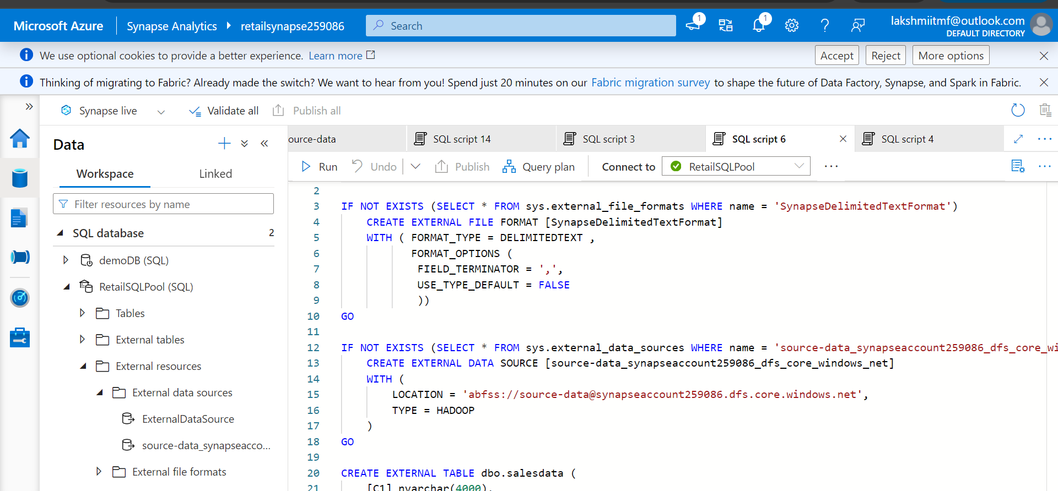

1. **Create External File Format:**

1. **Create External Table:**

**4. Transform and Analyze Data**

1. **Create SQL Scripts for Transformation:**
   * Write SQL queries to transform the data, such as aggregating sales by date and store.

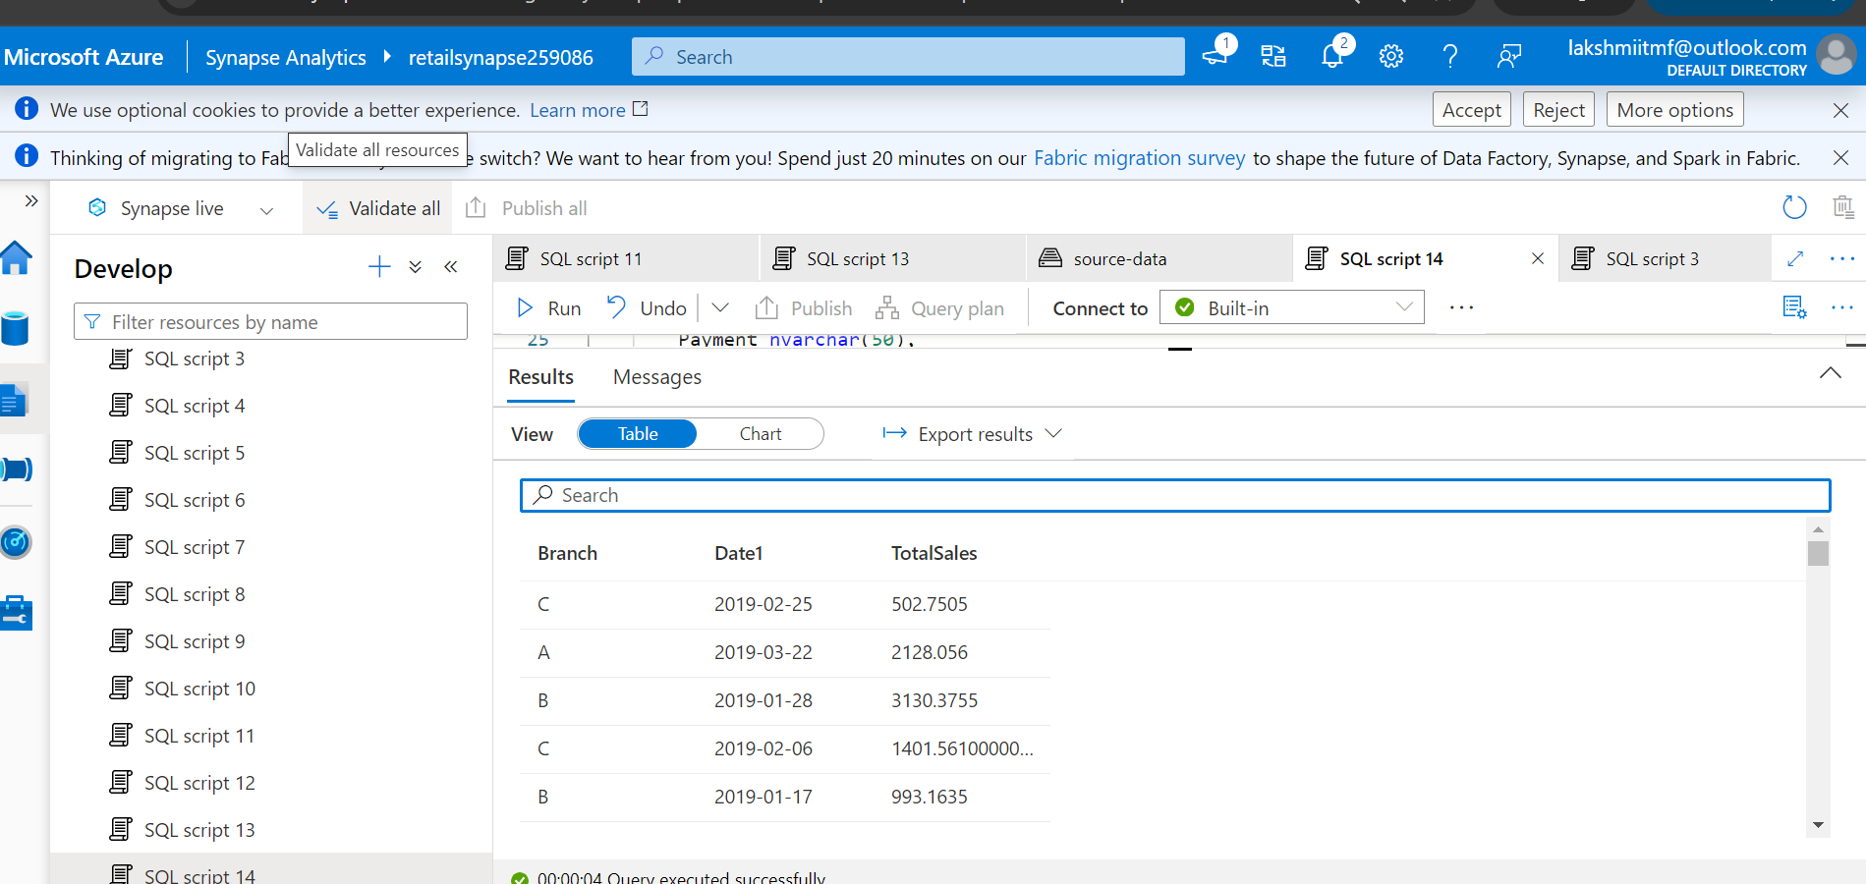

**\*\*\*\*\*\*\*\*\*\*\*\*\*\* ************* THANK YOU \*\*\*\*\*\*\*\*\*\*\*\*\*\*\*\*\*\*\*\*\*\*\*\*\*\*\*\*\*\*\*\*\*\*\*\*\***